Magnified Inch

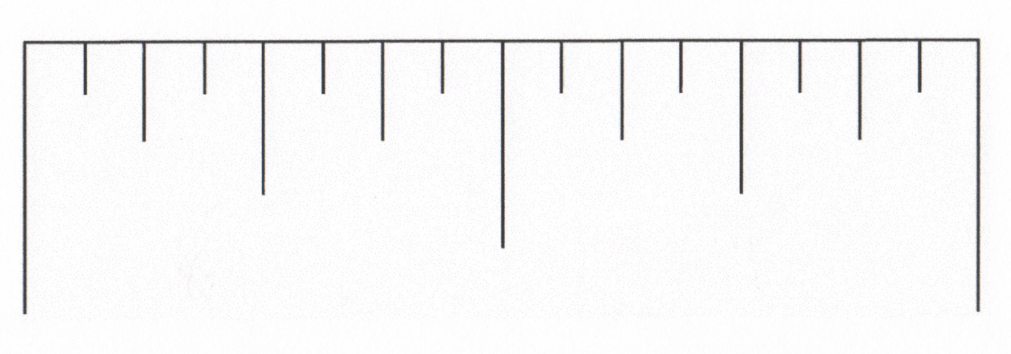

© 2013 by Susan O’Connell and John SanGiovanni from Putting the Practices Into Action. Portsmouth, NH: Heinemann. May be copied for classroom use.

