Focus on the Question
Boxes of Cookies Sold by Troop 328
Troop 328 sold cookies for the annual cookie sale. Each box of cookies was sold for $4.00. The graph shows the number of boxes sold.
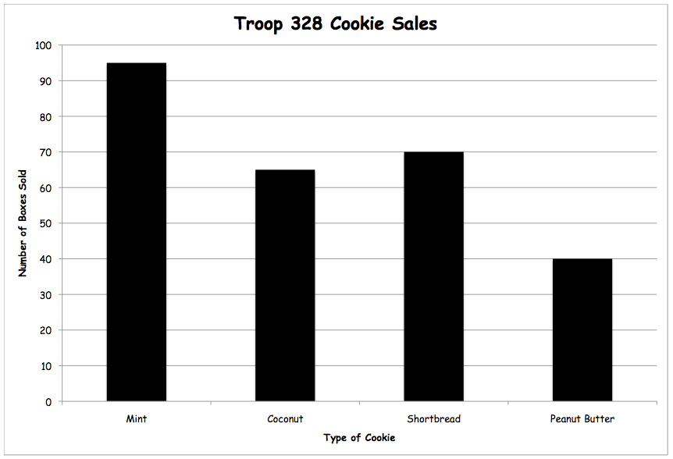

- How many more boxes of mint cookies were sold than shortbread? Tell how you would solve it.
- Bailey’s grandmother bought 4 boxes of coconut cookies and 2 boxes of mint cookies. How much did the cookies cost her altogether? Tell how you would solve it.
- Each box of peanut butter cookies contains about 20 cookies. About how many peanut butter cookies were sold by the troop? Tell how you would solve it.
- Molly sold ¼ of the boxes of peanut butter cookies sold by the troop. How many boxes did she sell? Tell how you would solve it.
- The troop got to keep $1.50 for each box of cookies they sold. How much money did the troop earn from selling cookies? Tell how you would solve it.

© 2013 by Susan O’Connell and John SanGiovanni from Putting the Practices Into Action. Portsmouth, NH: Heinemann. May be copied for classroom use.

