Focus on the Question

Allowances
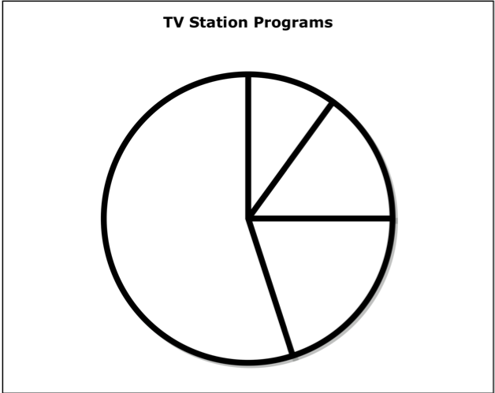
$0 - $5
55%
$11 - $15
10%
$16+
15%
$6 - $10

Allowances for Middle School Students

The circle graph shows the amount of allowance that middle school students earn for doing chores.

- What percentage of students surveyed earn $6 - $10? Tell how you would solve the problem.

- If 300 students were surveyed, how many students earn $0 - $5? Tell how you would solve the problem.

- If 70 students earn $11 - $15, how many students were surveyed? Tell how you would solve the problem.

- This survey shows the results of 600 students. If 60 more students were surveyed and each of them earned $0 - $5, how would the percentages of each amount change? Tell how you would solve the problem.

- 250 students were surveyed. What is the ratio of students who earn more than $10 to students who earn $10 or less? Tell how you would solve the problem.

© 2013 by Susan O’Connell and John SanGiovanni from Putting the Practices Into Action. Portsmouth, NH: Heinemann. May be copied for classroom use.

